Simulation – Experiment 1

# Scope

The scope of this document is reporting of experiments learning the use of simulation to support hardware design, based upon the Altera®’s Quartus ® II and ModelSim ®, software when developing for the non-Altera designed board from Master 21EDA.

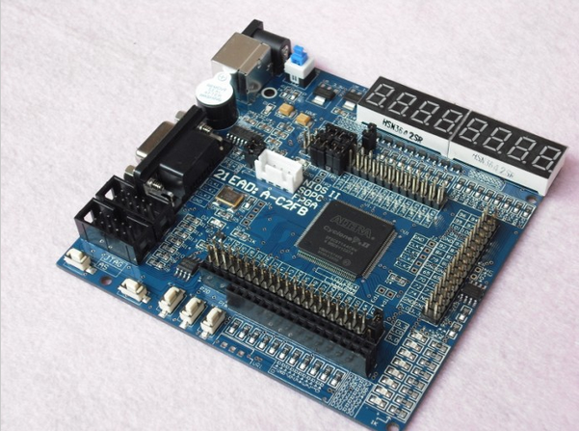

# References on Web Jump out to the interwebby thing

PDF Resources: Designing the Hardware

[1] [Introduction to Simulation of VHDL Designs](ftp://ftp.altera.com/up/pub/Altera_Material/10.1/Tutorials/VHDL/Quartus_II_Simulation.pdf)

[2] [Introduction to Simulation of VHDL Designs Using ModelSim Graphical Waveform Editor](ftp://ftp.altera.com/up/pub/Altera_Material/10.1/Tutorials/VHDL/ModelSim_GUI_Introduction.pdf)

# Introduction

The **Headings in red** in this document will mirror the headings in the Altera® tutorials so you can easily map between documents.

You **WILL NEED** Ref [1] and Ref [2] as this document is only providing the gotchas when walking through Ref [1] and eventually Ref [2].

Additional **Headings in blue** are internal to this document – used to break things up as you would expect headings to do.

Read the previous paragraph again. You are reading this document along with the Altera® tutorials Refs [1] and [2].

Remember also from the blog, we are using Quartus® II version 10.1 – driven by the chip on the board, the 144-pin EP2C5T144C8 Cyclone II.

Legend:

If I have been stumped by something I will use the image to the left to let you know a little investigation was in order.

If an important “Ah Ha!” moment occurred, I will also let you know.

If you’re to go to the web I will give the hint.

STOP, we are swapping tutorials

# QSIM Setup

We are using Ref [1] under this heading.

## 1 Introduction

Skim read this.

## 2 Installing the Qsim Tools

As mentioned in our previous experiment, the Qsim simulator is from the University Program download for Quartus® 10.1.

Step to fix.

From [Qsim download site](http://www.altera.com/education/univ/software/qsim/unv-qsim.html).

1. Set Download University Program VHDL 10.1 to get all the examples etc. to match 10.1 (Figure 1).

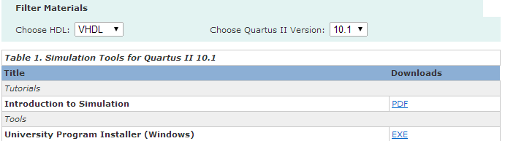

Figure 1. We start with 10.1 to match our version

1. Install, ignoring errors. This will install everything except the dang blasted Qsim (which isn’t in the distro). You will still get menu items for the simulator and the wave editor but nothing actually installed on disk.
2. Go back to web page and download 11.1 of the qsim.

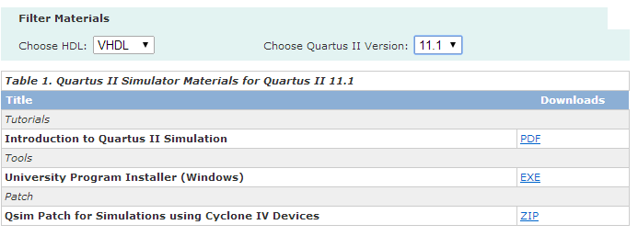

Figure 2. The cheat!!

1. The installer will detect your 10.1 (Figure 3).

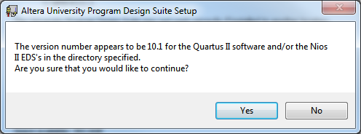

Figure 3. I can see you've a bit behind the world!

1. Turn everything off, except for the software installation, so we don’t overwrite our 10.1 files (Figure 4).

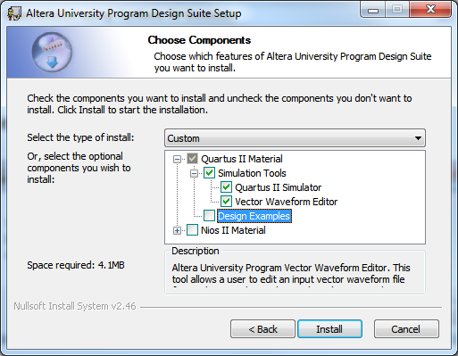

Figure . Just the software

## 3 Design Project

Yep, of course the code example won’t compile because of syntax errors. The correct code is as follows:

LIBRARY ieee;

USE ieee.std_logic_1164.all;

ENTITY majority3 IS

PORT(

x1, x2, x3 : IN STD_LOGIC;

f : OUT STD_LOGIC );

END majority3;

ARCHITECTURE majority3_rtl OF majority3 IS

BEGIN

f <= (x1 AND x2) OR (x1 AND x3) OR (x2 AND x3);

END majority3_rtl;

There were only subtle errors in the code above. Try working them out for yourself if you like.

Basically too, I built the project first and added a VHDL file via menus rather than, as suggested by the tutorial, coding the file outside and then creating project.

# ModelSim Setup

We are using Ref [2] under this heading.

## 1 Introduction

*Skim read this.*

## 2 Background

*Skim read this.*

## 3 Design Project

Using the CORRECT code from above – so we already have it written – create your simulation project in the same directory as the previous example.

## 4 Creating Waveforms for Simulation

Reading carefully, you’ll find the quirks are:

1. DO NOT UNDOCK THE WAVE EDITOR! The reason is that during the tutorial it will take you through the different ways of editing waveforms (using menus, buttons and various other routes to get to things). Turns out if you undock the wave editor, the buttons which are on the top menu bar whilst it is docked, that you’ll need to use, disappear when it is undocked – so you can’t follow the tutorial ().

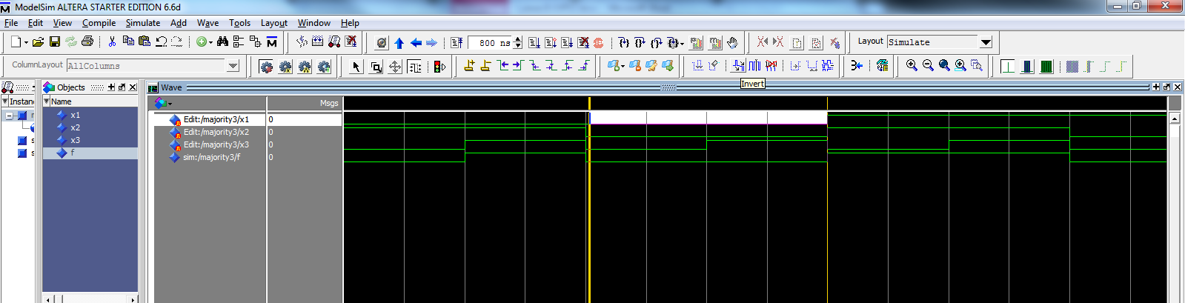

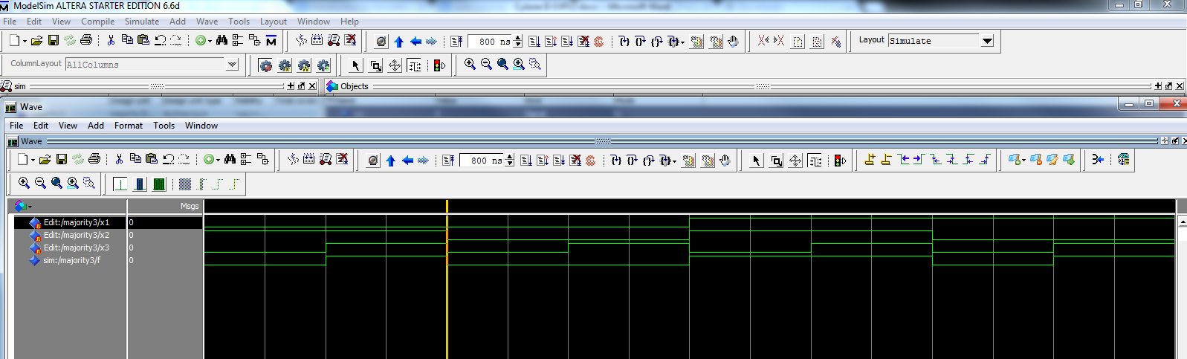

**?**

Figure 5. Missing buttons